Working with Widgets

Introduction:
A widget is an element of a graphical user interface (GUI) that displays information or provides a specific way for a user to interact with the operating system or an application.
Widgets include icons, pull-down menus, buttons, selection boxes, progress indicators, on-off check marks, scroll bars, windows, window edges (that let you re-size the window), toggle buttons, form, and many other devices for displaying information and for inviting, accepting, and responding to user actions.

What is a Widget ?
A web widget in simple terms is a client side, browser based application, with a small functionality, and which displays data coming from different sources.

We will create a basic Widget using HTML, CSS, and JavaScript. This chapter gives you a good starting point to understand the development of a web widget.

Widgets Overview:
The main functionality of the widget is to display data based on the data from the server and the parameter passed in the page. The most common data for a web widget is JSON (JavaScript Object Notation) file format. The reason being that, the JSON data can be used cross domain, so what that means is a JSON data can be residing in a different server and the web widget on a users page can include and use it using a function call. Essentially the JSON data becomes the part of the parameter of the function call.

Example:
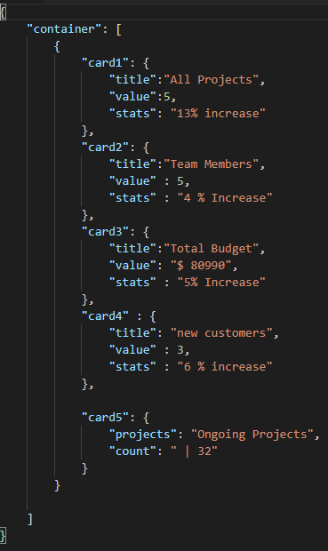

The actual JSON data can be an array of any number of key value pairs which follows the JavaScript object notation. More information at JSON.org. The ParseData function will be in another JavaScript file, say js.js file. And when the JavaScript file is loaded, the function is called and the JSON data is then parsed and displayed using Document.getElementbyid or Write.

The important point here is that the js.js file can be dynamically created on the server side, here it is JSON data but it can also be dynamically created series of JavaScript document.write lines which renders HTML directly. Although having JSON data gives modularity to the approach.

Architecture of Widgets:
Let’s now see the Hello World Widget architecture.

The architecture of a widget can be divided into three parts as shown below.
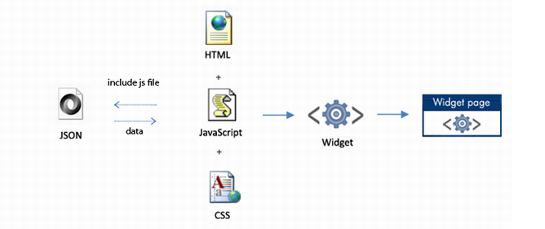
Data: The data of the widget, coming from data.js
HTML: The page which hosts the widget and passes the parameter to the Widget
JavaScript: The main functionality of parsing and displaying data
Images and Style: Presentation of the Widget

We will create a widget which takes the JSON data coming from the server/local and parses and displays it in the Widget.

Developing the Widget:

- Web page (testpage.html) where the Widget is hosted
- Bootstrap JavaScript file (bootstrap.js) which instantiates the Widget
- The core functionality (widget.js) of the widget which takes the data and displays it
- JSON data file (data.js) which is hosted in the server
- The presentation of the Widget (style.css)
- widget and the background

Widget Page:

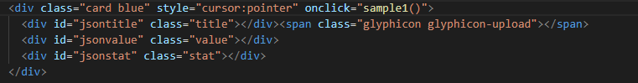
Here we have written a HTML code as Div element that will display a card that displays the Projects and the percentage increase.
This is the widget HTML code.

Bootstrap:

We can import Boot Strap and it’s functions to make it easy and lightweight for Dashboards.
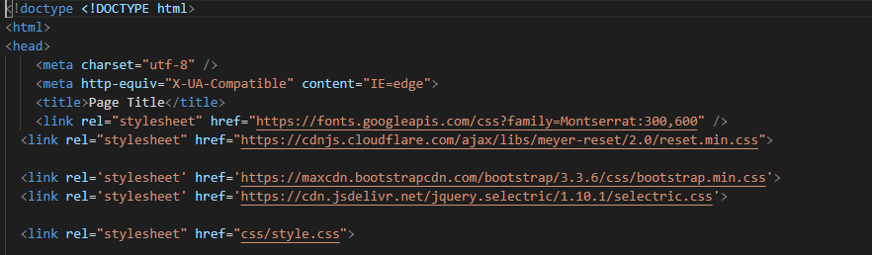

We Import Bootstrap templates using the same format as above.

Presentation with HTML, CSS and Images:

The first thing the bootstrap code loads is the style sheet because it should be loaded before we use it in the widget code. The presentation of the widget consists of both style sheet and the images which are used to display widget data. For our widget, let’s create a style.css and image(s) to be used for widget and background.
Create a new file Style.css and add it to your project. A separate stylesheet file allows you to change the look and feel of the widget without touching the widget functionality.
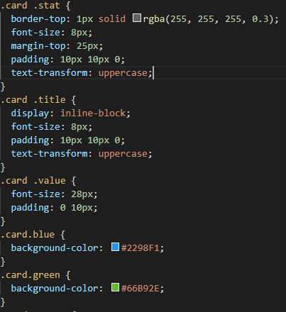
What happens is we had applied class as card on the DIV Element.
Card is parent class and blue is child class
And inside the DIV Element we have title, value and stat. .card .value and so on are applied as css styles in all the elements.

JavaScript Object Notation (JSON) Data:

As mentioned earlier, the js.js is basically a function call with JSON data as parameter. We will create the function sample1() in the js.js file. Note the key value pair for each parameter, each of them can be accessed using the dot notation in the called function. Next we will create the js1.js.
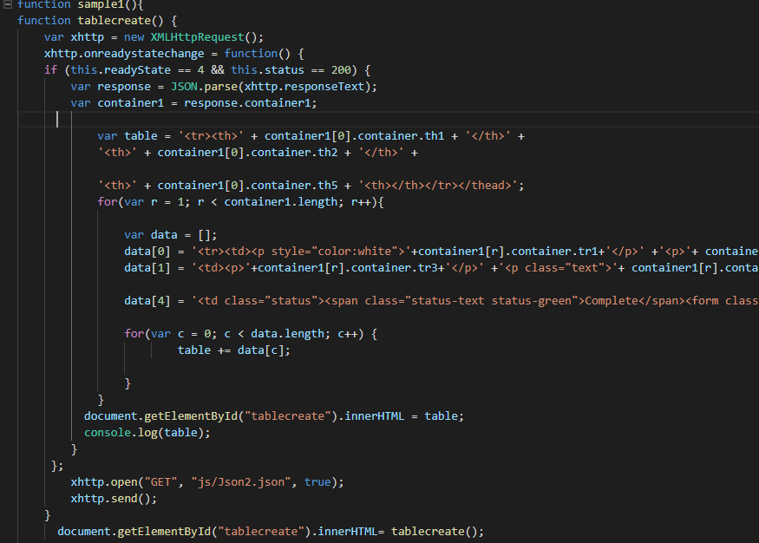
So I had defined the function sample1() as on click in HTML.
So I had also imported js1.js in the HTML.
When I click on Card Blue Widget. It displays the table using the content specified above in the js1.js file.

How Widgets are presented:

- The HTML page loads the widget with parameters
- When I click on the Widget, it refers to the function specified in js1.js and looks at the loop function to call data from json2.json.
- Widget calls the js1.js which has the dynamic content
- The style sheets are loaded for the widget presentation
- The widget functionality includes parsing the dynamic content
- The widget functionality uses parameters passed to render the final HTML code
- It Displays the table with required contents pulled dynamically out of Json page.

Before Click of Widget:
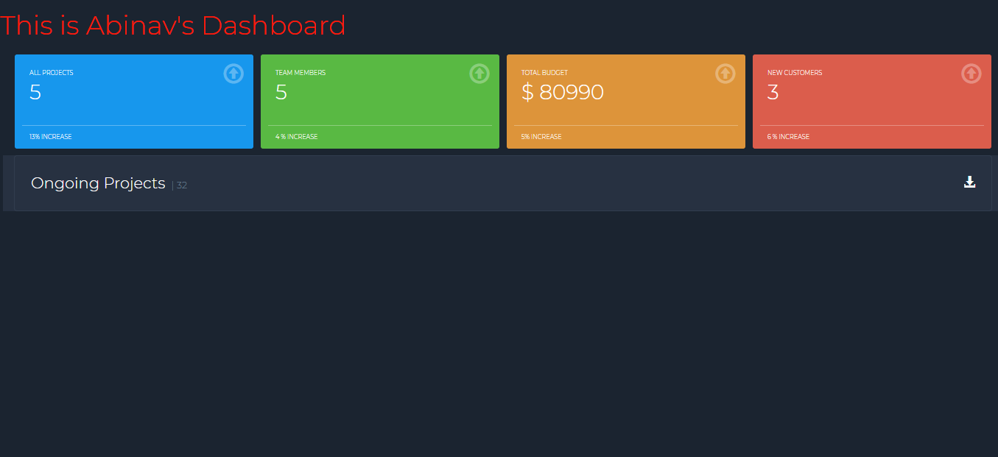
After Click of Widget:
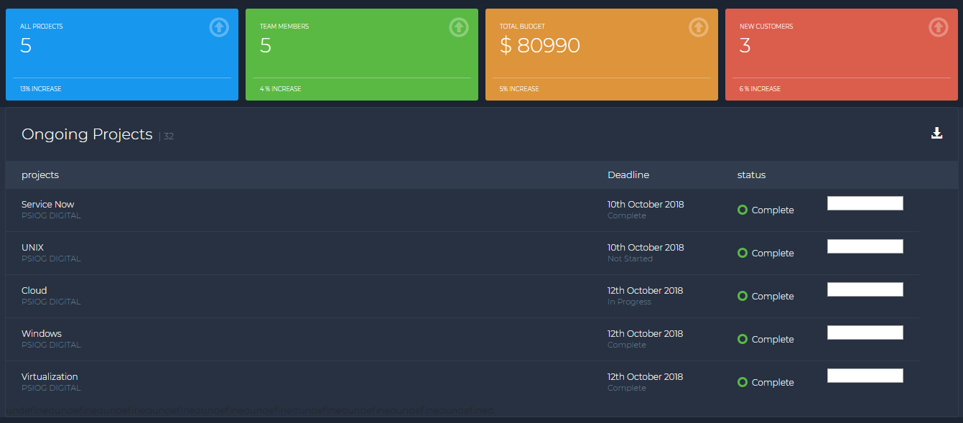

Summary:

In this short chapter, we learned how to create a Widget. We saw how a widget can display data from a remote/local server:

Widget can be divided into three parts:

- Core functionality in the form of Script
- Data from the remote host
- Presentation in the form of Style sheet and images

Widget interaction includes:

- Parameters passed from the page where it is hosted
- Dynamic data which comes from the server
- Script code which renders the Widget code based on the parameters and the data

References:

- Developing Web Widget with HTML, CSS, JSON and AJAX
- All about Web Widgets
- https://www.codeproject.com/Articles/81355/Chapter-5-Creating-Web-Widget-with-HTML-CSS-and-Ja

License:

This article, along with any associated source code and files, is licensed under The Code Project Open License (CPOL).

Declaration:
I hereby declare that the Project work entitled “Working with Widgets” is a record of an original work done by me under the guidance of Srinidhi Ramani, Mentor, Psiog Digital Pvt.ltd.

Abinav Ramesh
Psiog Digital

